|  |
| --- |
|  |
| Roshambo Game |
|  |
| Cert IV Programming |

**Sagun Shrestha**

December 12, 2016

Contents

Introduction: 2

Target Audience: 2

Purpose: 2

Screen shot against Bart as opponent: 4

Screen shot against Lisa as opponent: 5

Conclusion: 6

References: 6

# Introduction:

This is a simple program developed using Java programming to demonstrate the concept of classes, method and their attributes. It is developed using NetBeans IDE 8.1 as part of an assessment project for Certificate in Programming IV course. It is developed as a console application which focuses on object oriented development concept and methodologies. This project also demonstrates the use of various features that are available in the NetBeans IDE environment.

This program takes input from user as player one who plays against (Bart/Lisa) as opponent player in rock, scissors, paper game. A randomly generated value is used as input for Bart/Lisa whereas user inputs value for another player. Depending upon the values selected between two players, a winner is decided or a tie message is displayed.

The game keeps going on a loop until the player decides to end the game. Upon ending the game, simple statistics is displayed which shows the number of games won by user and (Bart/Lisa) and the number of ties between them. Overall, it is a simple and fun program developed to demonstrate the use of arrays, enumerators, classes, methods, if-else statements and the use of functions and subs.

# Target Audience:

This is a simple program designed to demonstrate object oriented concept in programming. It focuses on abstract classes and abstract method. It shows how derived classes can use the features and functionality of the base class. A method declared as an abstract can be used across sub classes derived from the base class and most importantly, the derived class can have their own implementation of the abstract method. So, this project is mainly targeted to those who wants to learn programming using object oriented concept and in the same time enjoy roshambo game while developing it.

# Purpose:

The purpose of this project is to demonstrate the understandability of java programming language and the concept of object oriented programming. This project mainly deals with classes, methods, enumerators and user validation techniques. It requires reading data from user and verifying it before using the data. It shows how abstract methods can be overridden and can have their own implementation across multiple sub-classes. The completion of this project allowed me to understand how to think and plan ahead before you start the project. It helped me to understand the flow of program logic and how the use of functions and subs break down the code into smaller manageable chunks which can be easily understood and reused.

List of Main Subs and Functions used in the program are listed below:

toString():

returns string value to the calling function.

compareValue(String userValue, String computerValue):

this sub compares two string values userValue and computerValue. Either a winner is decided or a tie between two values could occur. Subsequent message is sent back to the calling function.

startGame():

this sub holds the majority of the programming logic. It prompts the user to enter a name and select an opponent(Bart/Lisa). It asks user to make a selection from ‘rock’, ‘scissors’ and ‘paper’. Then a comparison is made using the compareValue function. The program keeps going until the user decides to quit the game. At the end, game statistics is displayed showing the respective number of games won by the user and the opponent.

generateRoshambo():

this method generates a random roshambo value from a pre-defined set of enumerator using a random generator. The randomly generated roshambo value is then returned back to the calling routine.

Program Guide:

1. Start the Roshambo Game.
2. Enter any name as a player.
3. Enter ‘b’, ‘B’, or ‘Bart’ to select Bart as opponent or enter ‘l’, ‘L’ or ‘Lisa’ to select Lisa.
4. Enter ‘r’, ‘rock’ or ‘ROCK’ to select Rock as user input.
5. Enter ‘s’, ‘scissors’ or ‘SCISSORS’ to select Scissors as user input.
6. Enter ‘p’, ‘paper’ or ‘PAPER’ to select Paper as user input.
7. A winner or tie is decided.
8. Enter ‘y’ or ‘yes’ to replay the game.
9. Enter ‘n’ or ‘no’ to quit the game.
10. Game statistics is displayed at the end of each game.

# Screen shot against Bart as opponent:

# 

# Screen shot against Lisa as opponent:

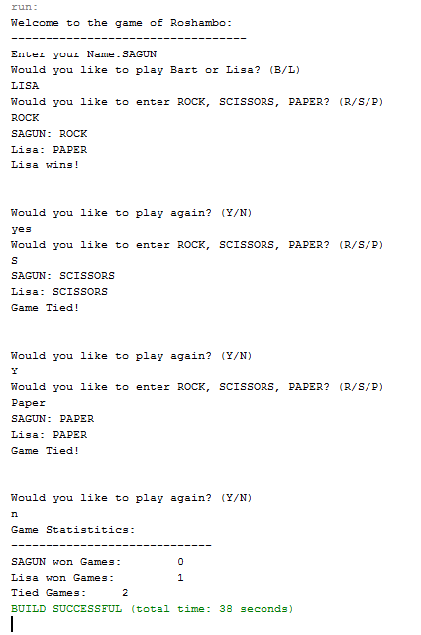

# Conclusion:

The completion of this project helped me to understand how object oriented concept can be used to simplify programming logics and how the use of methods and subs can divide a large program into small reusable chunks of code. This project helped me to identify the project requirements and find a systematic methodology to achieve the goal. I was able to implement abstract methods and enumerators with the ability to separate data and program logic using object oriented programming concept. Moreover, I learned how to manage program flow and validate user data with the use of iterative loops to accomplish the project goal. The NetBeans IDE environment made it so much easier to write and edit codes. It made finding and fixing errors using the debug mode a lot easier and less troublesome.

# References:

* [www.wikihow.com](http://www.wikihow.com)
* [www.stackoverflow.com](http://www.stackoverflow.com)